1. **What is API Management & why we going for APIM**

* It is fully managed service
* Using APIM we can publish, Maintain and Monitor API’s
* Major drawback for APIs is that one cannot track the utilization of the APIs
* Instead of accessing the API directly, you can register API into APIM. Therefore, user cannot directly access API instead of going APIM. Now APIM take care of authorization, Oauth and Open ID connect and all
* This is not just about authenticating and authorizing access to API’s, it is about policies like rate limit, quota, XML to JSON conversion etc.
* One can also apply authentication on the API and authorize application to access the API

1. **Have you created any policies in APIM?**

* Using policies, it will change the behavior of API through configuration.
* Policies like conversion from XML to JSON and restrict the amount of incoming calls from a developer
* Restrict the incoming call from IP addresses
* <https://docs.microsoft.com/en-us/azure/api-management/api-management-howto-policies>
* <https://docs.microsoft.com/en-us/azure/api-management/set-edit-policies>

1. **What is Rest API?**

* Rest API and Restful API both are same
* Normally API used to communicate with other server to get data or value by passing input. The responses from server could be XML or JSON. For example if you want to get values of city name of country, you giving the request country name then server response the city name in JSON or XML format. To achieve this we need to create GET method and request with parameters
* Instead of getting the data from server, we can have object of the data from server
* That’s the advantage of REST API
* It’s a stateless
* Developer no need to install any additional libraries when you creating Rest API
* It can return different data types like XML, JSON, YAML and other data format depends on what client required
* Disadvantages is not maintain the data in session means it is stateless
* An **API** is an application-programming interface. It is a set of rules that allow programs to talk to each other. The developer creates the API on the server and allows the client to talk to it
* When you use the create, read, and update operations (POST, GET, and PUT), you can include the optional format query parameter to adjust the JSON output for specific use cases

1. **Difference between SOAP API VS REST API**

* SOAP uses only XML for exchanging information in its message format whereas REST is not restricted to XML and its the choice of implementer which Media-Type to use like XML, JSON, Plain-text.
* Benefits of SOAP over REST as SOAP has ACID complaints transaction. Some of the applications require transaction ability which is accepted by SOAP whereas REST lacks in it.
* If there is no need to maintain a state of information from one request to another then REST should be used. If you need a proper information flow wherein some information from one request needs to flow into another then SOAP is more suited for that purpose. We can take the example of any online purchasing site. These sites normally need the user first to add items which need to be purchased to a cart. All of the cart items are then transferred to the payment page in order to complete the purchase. This is an example of an application which needs the state feature. The state of the cart items needs to be transferred to the payment page for further processing

1. **How can we send message in order wise in service bus queue?**

Follows FIFO, the order in which they were added to the queue

1. **How to implement security for function app?**

* We can implement through AD Authentication with login or client ID. There is feature called authentication/authorization in platform feature. There we have to give type of authentication like (AD, Microsoft account, Facebook, twitter)
* We can secure through API Management. When we register function app URL we will get token. So when never we calling the function app have to pass the token as well in the header

1. **What is logic app?**

* Used for creating workflows
* It provides a visual designer for configuring the workflows.
* You can define a workflow with connectors and logic creation using inbuilt standard connectors
* Logic Apps is a fully managed IPAAS (Integration platform as a service)

1. **How to send data transfer from one mail to another mail in logic app?**

* Select Gmail, outlook, or office 365
* Select When new mail arrives
* Then choose folder like inbox or spam and choose attachment (yes or no) then interval means time( 1min once)
* Add another connector and choose required fields like (body, attachment) from right side which is displayed

1. **What is event hub?**

* Its event processing cloud services
* It can process million and millions of events per second and make them available for storage
* Its scalable
* It will process millions of record in both inbound and outbound direction
* Real time scenario like game application
* Even we can connect event hub is source connector for service bus queue
* Application use - <https://codewithsarath.com/real-time-twitter-sentiment-analysis-with-azure-stream-analytics-and-cosmos-db/>
* Create an event hub for Streaming Analytics input
* Grant access to the event hub in Shared access policies, click the Add button
* Create a Twitter application
* Configure the WPF Twitter client application
* Click the green “Start” button to collect the social sentiment data
* Create a Stream Analytics job
* Azure Stream Analytics job supports three input types. Please choose Event Hub as we use this service for the data streaming
* Create an output sink
* You can also push your results to Azure Blob Storage, Azure SQL Database, Azure Table storage, Event Hubs, or Power BI, depending on your application needs

1. **What is event grid?**

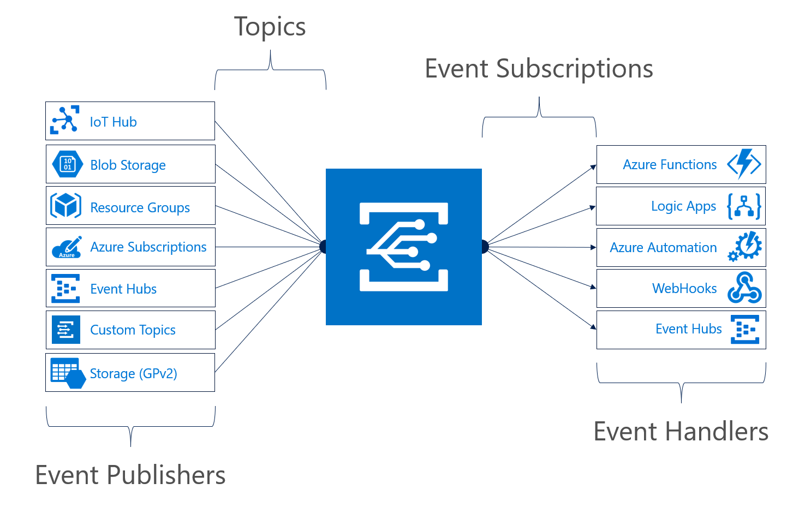

* It’s used for handle or manage the events across different azure services or resources
* Used in like azure logic app, Functions
* An event source pushes events to Azure Event Grid, and event handlers subscribe to events. An event source or publisher – an Azure service like Storage, IoT Hub, or a third party source emits an event, for instance, blob Created or blob Deleted. You can send the event to a topic.  Each topic can have one or multiple subscribers (event handlers).  You can configure an Azure Service, if supported, as an event publisher or you create a custom Azure Event Grid Topic. Subsequently, the event handlers in Azure like Functions, Web Hook, and Event Hubs can react to the events and process them.

1. **Difference between Event grid & Event Hub**

Event grid will not process the objects (like files). It will process only events (like messages) but event hub will process objects and events as well

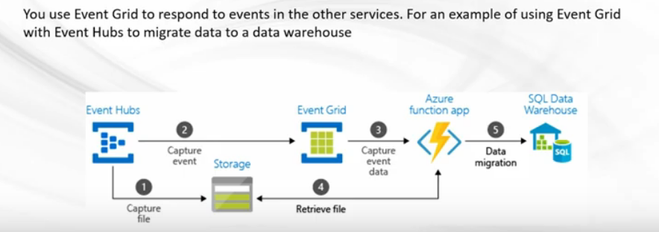

* When to use **event hub** – it will process millions of events per seconds
* For example, voting system in live concert, there will be thousands or lakhs of peoples will vote same time. Therefore, in this scenario we can go for Event hub
* It will process the events or objects from multiple sources

1. **Where will use service bus queue**

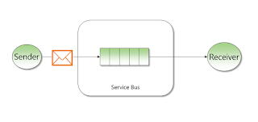

The application gets a huge number of recharge requests during the peak hours and is not able to process each request, so the company is looking for something like where all the requests are parked when they come and process one by one

* There is support for dead lettering, which allows us to move automatically a message in a secondary queue, if the message expires or clients cannot consume a specific message
* There is full support for transactions, handling a specific number of messages in the same transaction
* An interesting feature of Azure Service Bus Queues is duplicate detection. Once it is activated, we can detect duplicate messages. The moment we want to add a message that already exists in the system, the message will not be added

1. **Functions use case**

* “Serverless Computing" doesn't really mean there's no server. Serverless means there is no server you need to worry about
* We can write our code directly to the portal or can setup continuous integration and deploy our code through Azure DevOps, GitHub, or any other supported development tools
* It allows us to write a function in the language of our choice, such as C#, F#, Java, PHP, JavaScript, etc
* Azure Functions allow us to download code dependencies from NuGet and NPM, so we can use libraries that need to execute our code and are available on either NuGet

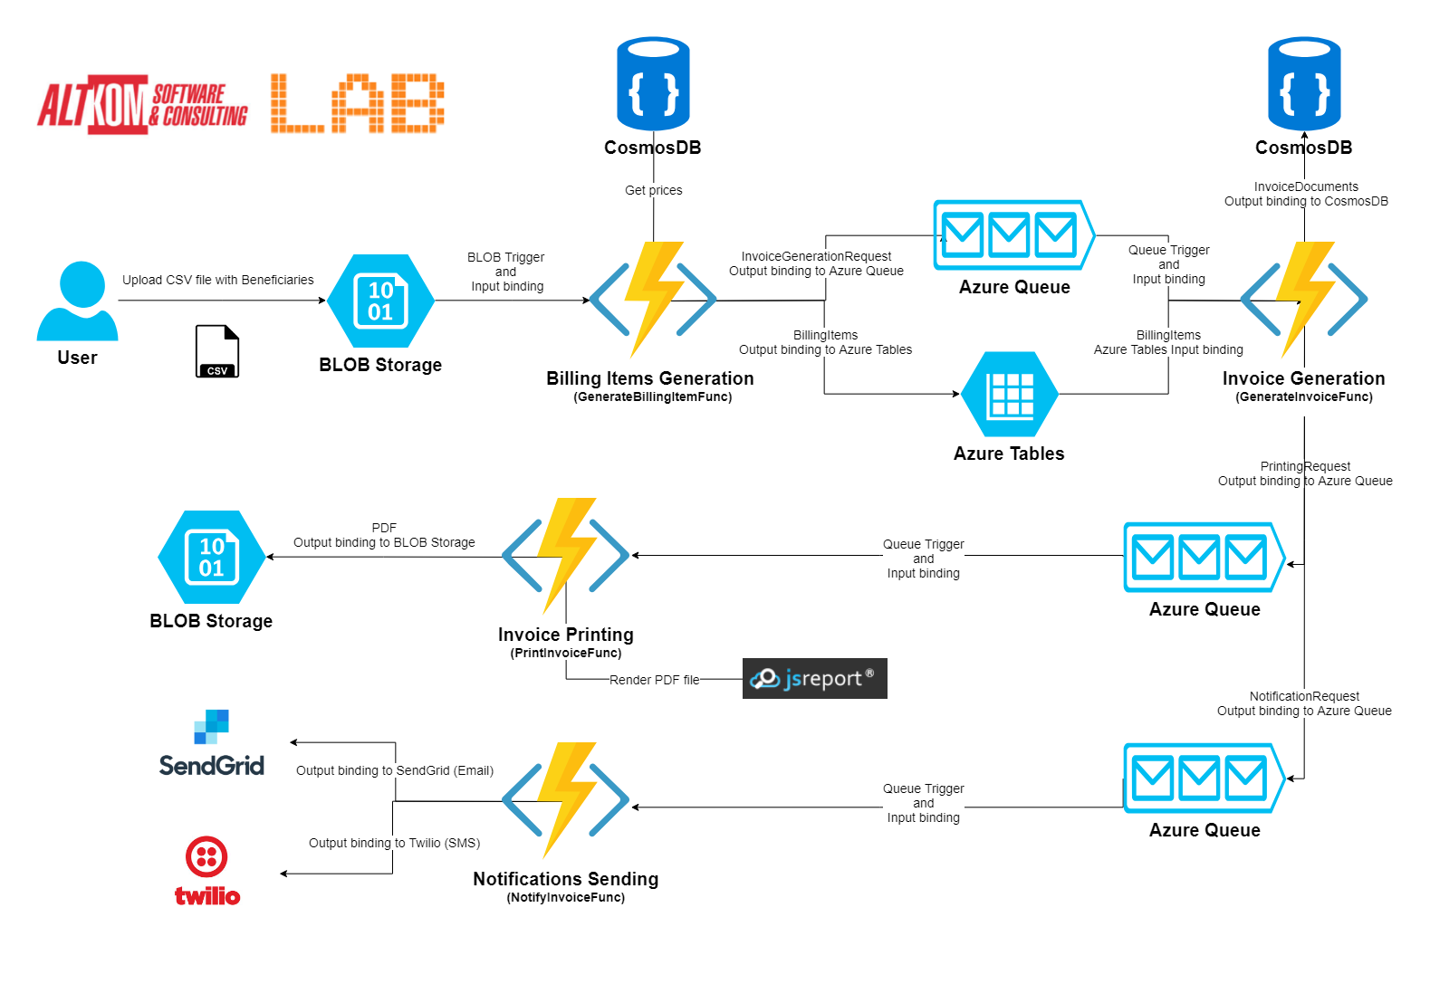

* User uploads a CSV file with Beneficiaries to a specific data storage – Azure Blob Container.
* The above action triggers a function GenerateBillingItemsFunc that is responsible for:
  1. generating billing items, which use prices from an external database – CosmosDB and saving them in the table – Azure Table;
  2. sending message about the need to create a new invoice to Azure Queue;
* When a new message appears on the queue, the next function is triggered (GenerateInvoiceFunc). This function creates domain object Invoice and saves this object in database – CosmosDB. After a successful save, it sends a message to two Azure Queues.
* When a new message appears in one of queues, the function PrintInvoiceFunc is triggered. This function uses external engine to PDF generation – JsReport and saves a PDF file in Azure Blob Storage.
* When a new message appears in the second queue, the function NotifyInvoiceFunc is triggered. This function uses two external systems – SendGrid for email sending and Twilio for SMS sending

1. **Azure CDN**

Azure CDN, caches all the static contents(Images, Videos, Style sheets, documents, files, Client-side scripts and HTML pages) that you have in your website to customers from server that is closest to user region

So it will reduce the round trip

Initially first request checks from edge server, if no contents in edge server it will request to origin server and stored in edge server. From next request it will get content from edge server

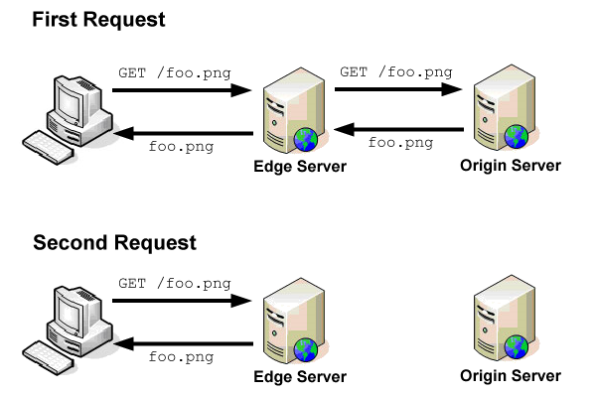

1. **Redis cache**

* Modern applications mostly work with a large amount of data. In this scenario, when you retrieve data from a database, it typically finds the table and gets the results that it sends back to the user. The performance, in such case, goes down due to multiple requests. So, to reduce some number of requests, you can use cache data that does not change frequently
* Redis Cache is an open source, in-memory database that is used for improving the performance of an application by retrieving and storing the data in the cache memory using a Key-value format. Azure Redis Cache is a feature-rich functionality that gives you access to secure, low-latency, high-performance throughput

1. [**Could we able to move the services from one Resource Group to Another?**](https://www.besanttechnologies.com/windows-azure-interview-questions-and-answers)

Yes. We can move. From top of the resource group options called **MOVE**. If you click that option, it will ask resource group name to move. Even we can move from one

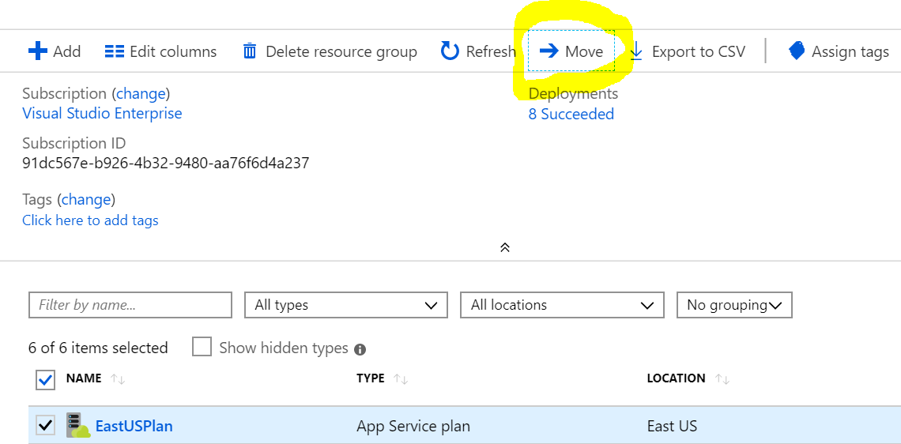

1. [**Can we able to restrict database port number to communicate only to Application Server**](https://www.besanttechnologies.com/windows-azure-interview-questions-and-answers)

Yes we can that could be possible in Network Security Group.

1. **What is topic and queue & which scenario we will use in service bus queue?**

**Queue**

* + One sender and one receiver
  + There is support for dead lettering, which allows us to move automatically a message in a secondary queue, if the message expires or clients cannot consume a specific message
  + There is full support for transactions, handling a specific number of messages in the same transaction
  + An interesting feature of Azure Service Bus Queues is duplicate detection
  + Real-time example: mobile recharge based on network, offer will send messages to customer
  + If you are using the basic tier, then you only have the one option – queues.

**Topic**

* + Azure Service Bus Topics allow us to deliver messages one-to-many
  + Each topic that is used to send messages can have maximum 2000 subscribers. This means that the same message can be received by 2000 subscribers
  + An interesting feature is the filter support. We can attach a filter to each subscription. That filter will allow only the messages that respect the filter rule to reach that specific subscription
  + Real-time example: sample recharge application, company wants to give some offer on regular customer So now will send same format message much number of customers
  + Topics are only supported in the standard and premium tier.

1. **How many hours message will be in queue?**

14 days (we can change)

1. **How many types of blob types?**

Azure Storage supports three types of blobs:

**Block blobs** store text and binary data, up to about 4.7 TB. Block blobs are made up of blocks of data that can be managed individually.

**Append blobs** are made up of blocks like block blobs, but are optimized for append operations. Append blobs are ideal for scenarios such as logging data from virtual machines.

**Page blobs** store random access files up to 8 TB in size. Page blobs store virtual hard drive (VHD) files and serve as disks for Azure virtual machines.

1. **You have API, want to get output difference format (json, XML, text) from three different customers what will do?**

* We can convert the output format from **Result filter**
* Based on input parameter we can change the output format
* Using Result filter we can convert the required **output format**

1. **Where to use function app?**
2. **If you have web app which one, will you choose PAAS service or IAAS service?**
3. **Which scenario choose load balancer? How to achieve load balancer? How to check that whether it is working or not?**
4. **How to solve bulk insert, contains, CLR query in azure sql**
5. **Challenges in docker compose**
6. **Challenges faced in sql db migration**
7. **How to expose and create API**
8. **Challenges faced in sql db migration using adf**